Hydrodynamic modelling and impact of environmental watering on Ruppia tuberosa and fish habitats in the Coorong
Klaus D. Joehnk, CSIRO Land and Water
Jason Nicol, SARDI
Qifeng Ye, SARDI
2014-04-24 – internal document, not for release

Hydrodynamic model and flow scenarios

Coorong Hydrodynamic Model
The hydrodynamic model used in this study was developed by CSIRO over the past years (Webster 2007; Webster 2013) and is now available as Coorong Hydrodynamic Model (CHM) v2.1 (Joehnk and Webster 2014). CHM solves equations of motion (flow), conservation of volume (water level), and salt balance (salinity) along the Coorong gridded with 1 km cells. Water level and salinity is simulated with daily time steps on the 102 cells of model geometry from the Murray Mouth to past Salt Creek at the south end of the South Lagoon. The model describes how water moves and salt is distributed in response to water level variations and the stress of the wind on the water surface as well as the total water inputs and outputs including evaporation, precipitation, USED flows, and barrage flows. To describe the variability of these variables for the entire Coorong, the model was extended to include also the smaller Goolwa Channel extending from Murray Mouth to Goolwa Barrage 1 (Joehnk and Webster 2014), which is however not used in this report.
The hydrodynamic model is based on daily barrage flow values from 1963 and updated regularly, currently until 31 August 2013 (data provided by MDBA, Jim Foreman, 2013-11-18). Salinities as well as water level along the Coorong North and South Lagoon were calculated on a daily timestep with 1 km resolution driven with hourly and daily datasets describing tidal forcing, wind velocity, evaporation and precipitation. Model results for salinity and water level above AHD for the whole period 1963 – 2013 are shown in Figure 1. Since we mainly deal with thresholds for habitat modelling, here we exemplify results for a water level threshold of 0.2 m AHD and a salinity threshold of 85 g/L. While water level will modify outcomes of habitat modelling, the main driver is the salinity tolerance of species. The threshold value used in Figure 1 is indicative for higher salinity tolerant juvenile fish. It can be used as a first impression on habitat suitability.

Flow scenarios
To evaluate the effect of environmental water on ecosystems three scenarios were calculated for the 2012-13 watering year. These scenarios are based on modelled percentage environmental water (TLM and CEW) at Wellington as provided by the MDBA (Table 1) and used for the actual barrage flow values to generate 3 scenarios:
- Reference, including all water sources
- With CEW, without TLM water
- Without CEW, without TLM water
All scenarios were started from 1963 and include changes due to environmental watering only for the last simulated year, 2012-13. Changes in water level and salinities with respect to the reference for 2012-13 are given in Figure 2. Differences for scenario 2 are low but can become large for scenario 3 in the South Lagoon. The bigger changes are due to the larger contribution of CEW in the summer months. The results of the three scenarios (reference run 1963-2013, and two scenarios of diminished flow – as defined above) were used to simulate habitat characteristics for Ruppia tuberosa as well as fish species.
Table 1: Water contributions at Wellington as used in the barrage flow scenarios.
Month | % TLM | % CEWO | % E Water
201207 | 0% | 0% | 0%
201208 | 0% | 0% | 0%
201209 | 0% | 0% | 0%
201210 | 0% | 0% | 0%
201211 | 20% | 14% | 34%
201212 | 22% | 43% | 65%
201301 | 5% | 59% | 64%
201302 | 26% | 29% | 55%
201303 | 11% | 47% | 59%
201304 | 0% | 61% | 61%
201305 | 0% | 53% | 53%
201306 | 0% | 39% | 39%
201307 | 0% | 9% | 9%
201308 | 0% | 0% | 0%

Fish habitat model
The basic fish model is analysing salinity thresholds for juvenile fish on an annual basis (“habitat suitability”) and on a daily basis. The annual analysis provides probabilities of habitat suitability by calculating the annual exceedance probability for a certain salinity threshold. A simpler approach only detects the extend of a certain salinity threshold on a daily basis (“threshold analysis”) along the Cooorong starting at the Murray Mouth. The latter basically gives a simplified picture of the salinity contours along the Coorong ovr time.

Annual habitat suitability
The fish model is looking for suitable habitats for juveniles of different fish species in the Estuary, North Lagoon and South Lagoon of the Coorong, depending on ambient salt levels for a period of one watering year. Each fish species is characterised by a certain salt tolerance threshold, which varies between seasons (Table 2). In our simplified expert model type system, the cold months include the period from mid April to mid October and warm months include the period from mid October to mid April. To account for timing of management strategies this is split to financial years, thus using divided cold seasons before the warm season (c1: 1. July to 15. October) and after (c2: 16. April to 30. June). The model is effectively calculating an annual exceedance probability for salinity. It takes the salinity output of the hydrodynamic model, s(x_{j},d), given on a 1 km grid (x_{j}, j=1(1)102 km) along the Coorong with a daily resolution (day d), and counts the number of days (n_{f}) where salinity is below the specific threshold, x^{w}_{f} of a fish species, f, in one of the periods (superscript c1 and c2 for cold periods, and w for warm half year) at each spatial grid point over all available years (y). The probability that a grid point (j) is a suitable habitat is then defined as
P^{w}_{f}(y) = n^{w}_{f}/N^{w}(y), and equivalently for P^{c1}_{f}(y), P^{c2}_{f}(y)
where N^{w}(y) is the total number of days in the period (here the warm period, w) of the year y. Be aware that the number of days is not constant but changes for a leap year. The final probability of a suitable habitat over a years time is then calculated as
Pf(y) = (182*P^{w}_{f}(y) + 107*P^{c1}_{f}(y) + 76*P^{c2}_{f}(y+1))/365
recognizing that the length of the individual periods is
N^{w}(y) = 182 (or 183), N^{c1}(y)=107, N^{c2}( y+1)=76 with N^{w}(y)+N^{c1}(y)+N^{c2}(y+1)=365 (or 366),
and that the second cold period is accounted for the next year, y+1.

Species name | Threshold cold month [g/L] | Threshold warm month [g/L]
Mulloway | 60.3 | 51.1
Tamar goby | 67.7 | 66.3
Black bream | 78.6 | 81.8
Greenback flounder | 81.1 | 72.9
Yelloweye mullet | 83.8 | 68.3
Congolli | 89.5 | 86.9
Smallmouthed hardyhead | 99.5 | 97.1
Table 2: Period specific salinity thresholds for suitable habitats for seven fish species.

Daily fish threshold analysis
To create an overlook over suitable habitats on a daily basis, we also calculated the distance from the mouth (or the number of 1 km wide cells in the underlying hydrodynamic model) to which a certain threshold of salinity is not surpassed. This is effectively a simplified contour plot depicting regions below and above a certain salinity threshold (see e.g. Figure 1). As above, thresholds can vary between different periods (here warm and cold), and the same threshold values as given in Table 2 also apply here.

Ruppia tuberosa ecological response model

Background and biology
Ruppia tuberosa is a submergent halophyte that was historically common in the South Lagoon of the Coorong (Geddes and Brock 1977; Brock 1979; Brock 1981; Paton 1982; Geddes and Butler 1984; Geddes 1987; Paton 1996). It is one of the most salt tolerant angiosperms with a maximum salinity tolerance of 230 gL⁻¹ for adult plants (Brock 1982a); however, much lower salinities are required for life cycle completion. Kim et al. (2013) reported that salinities lower than 85 gL⁻¹ for 15 days are required for germination from seeds and 125 gL⁻¹ for sprouting from turions. Furthermore, exposure to elevated salinity followed by lower salinity stimulated germination in seeds but reduced viability of turions by over 90% (Kim et al. 2013). Brock (1982b) also noted that at elevated salinities Ruppia tuberosa did not flower and was restricted to reproducing asexually; therefore, lower salinities are required for the production of seed and subsequent replenishing of the sediment propagule bank.
Water levels are also a critical factor for Ruppia tuberosa in the South Lagoon of the Coorong. Ruppia tuberosa is highly sensitive to desiccation but has high light requirements; therefore, there is a narrow band where the species can occur in the highly turbid South Lagoon (Nicol 2005). Ruppia tuberosa colonises areas between 0 and -0.5 m AHD in May to June in the South Lagoon; areas below -0.5 m AHD are below the euphotic zone and areas above 0 m AHD are prone to desiccation due to wind driven water levels fluctuations (seiching) (Nicol 2005). These water levels need to be maintained until at least mid November, preferably mid to late December to ensure the life cycle is completed and the seed bank replenished.
Figure 3 represents the ideal hydrograph for Ruppia tuberosa in the South Lagoon of the Coorong, where the water level reaches +0.4 m AHD at the beginning of May and is maintained until mid December. A suboptimal scenario where water levels reach +0.2 m AHD at the beginning of June and are maintained until mid November is also presented. Both should result in life cycle completion; although, the optimal scenario is preferable. The upper and lower colonisation elevations are also presented (Figure 3).
Figure 4 represents optimal the salinity regime for Ruppia tuberosa in the South Lagoon of the Coorong. The salinity needs to be lower than 125 gL⁻¹ for turions to sprout and 85 gL⁻¹ for seed germination for at least 15 days (Kim et al. 2013). The salinity needs to be maintained below 100 gL⁻¹ for the duration of the growing season to ensure plants reproduce sexually. Whilst seed production is restricted at salinities above 100 gL⁻¹, turions may be produced but this requires further study. The maximum salinity thresholds for adult plants (230 gL⁻¹), turion sprouting (125 gL⁻¹), seed germination (85 gL⁻¹), sexual reproduction (100 gL⁻¹) and turion viability (130 gL⁻¹) are also represented.
The information in Figure 3 and Figure 4 are summarised in Figure 5, a conceptual model that represents the life history of Ruppia tuberosa in the South Lagoon of the Coorong. The life history of Ruppia tuberosa is represented by five stages; the sediment propagule bank, seedlings, juveniles, asexual adults and sexual adults. The sediment propagule bank consists of seeds and turions; turions will sprout (in May to June) when inundated with water that has salinity lower than 125 gL⁻¹ and seeds will germinate when the salinity is below 85 gL⁻¹ (Kim et al. 2013). Seedlings will persist and become juveniles providing the water level is maintained above +0.2 m AHD and the salinity remains below 100 gL⁻¹ and in turn juveniles will become asexual adults if the aforementioned conditions are maintained until October. If the salinity remains below 100 gL⁻¹ and the water level above +0.2 m AHD until mid November (preferably mid to late December) the plants will reach sexual maturity and replenish the propagule bank. However, if the salinity exceeds 100 gL⁻¹ the plants will not flower but turions may be produced that will partially replenish the propagule bank. If water levels fall below +0.2 m AHD before mid November plants will die and the propagule bank will not be replenished.
The ecological bottle necks identified were seed germination and turion sprouting because during periods of extended barrage closure the salinity in May and June often did not fall below the thresholds germination or sprouting (Figure 5). Furthermore, the high salinities experienced over summer during periods of extended barrage closure may have reduced turion viability in the propagule bank. The other bottles neck identified were plants not reaching sexual maturity and the propagule bank not being replenished (Figure 5). Barrage outflows often cease during late October to early November, which causes a sudden drop in water level in the South Lagoon, stranding plants that have not reached sexual maturity.

Ruppia tuberosa response model
Using the information presented in the previous section an ecological response model that calculated the probability of Ruppia tuberosa replenishing the sediment propagule bank based on modeled hydrological conditions was developed. The model is reading the output of the Coorong Hydrodynamic Model, CHM v2.1 (Webster 2007; Webster 2013; Joehnk and Webster 2014), i.e. daily values of salinity and water level along the 102 cells of the model geometry over the modeling period 1963 to 2013. For the purpose of modeling, each life history stage was treated as occurring over a discrete time period (in nature there would be considerable overlap of life history stages) and a survival probability calculated for each time block that was in turn used to calculate the probability of replenishing the sediment propagule bank.

Model processes
Model processes are chosen according to the preceding discussion. They are seed germination, turion sprouting, seedling development to juvenile plants, juvenile development to asexual adult plants, and asexual adult development to sexual adult plants, which are defined further below. Each process is assigned a survival probability, which in the end results in a combined probability of sediment propagule bank replenishment.

Seed germination
Starting with the first day of the life cycle (May 1st), all periods of the preceding 15 days (the time required for germination (Kim et al. 2013) are analysed (e.g. for May 1st the conditions on April 16th to April 30th are analysed, for May 2nd conditions on April 17th to May 1st are analysed etc.). Over these periods a condition for germination is implied: salinity over the 15 day period<salinity threshold (85 gL⁻¹) for each day in the period and water level over the 15 day period>water level threshold (+0.2 m AHD) for each day in the period. If true, this day is counted as possible germination day. Subsequent days were analysed over the germination period (May 1st to June 30th) the same way. The sum of all possible germination days in the period, divided by the total number of days (61) gives a probability of germination, Pgerm, during this period.
After germination it is assumed that the seedlings will survive until to the next block (seedling development into juvenile plants), which is a problem introduced by assuming fixed development periods and needs to be taken into consideration when interoperating model outputs.
Turion sprouting
Turion sprouting probability (Psprout) is calculated using the same method, over the same period as seed germination with the salinity threshold increased to 125 gL⁻¹.
Seedling development to juvenile (non-reproductive) plants
Survival probability in the seedling to juvenile development period (June 1st to July 31st) was calculated slightly differently. If the hard threshold was given for all days, probably none would survive. To avoid this we tested against the mean salinity and water level over the period. This would result in an all or nothing survival rate for the period (0 or 1). To weaken that we decided to test each day for survival conditions: salinity (day in period) < salinity threshold (100 gL⁻¹) and water level (day in period)>water level threshold (+0.2 m AHD), if true survival=1 for this day
(effectively this type of condition is the same as for germination, only setting the length of condition analysis to one day instead of the previous 15). The sum of all possible seedling survival days in the period, divided by the total number of days (61) gives a probability of seedling survival, Pseed, during this period.
Juvenile development to asexual adult plants
Survival probability in the juvenile development to asexual adult period is calculated using the same method as seedling survival probability but the period spans July 1st to October 31st), resulting in a juvenile survival probability, Pjuv. At this stage, the combined probability for a seedling to reach the adult stage is set as 0.5*(Pgerm+Psprout)*Pseed*Pjuv.
Asexual adult development to sexual adult plants
Survival probability in the asexual adult to sexual adult period is calculated using the same method as seedling survival probability but the period spans October 1st to December 31st), resulting in an adult survival probability, Padult. At this stage, the combined probability for a seedling to reach the sexual adult stage is set as 0.5*(Pgerm+Psprout)*Pseed*Pjuv*Padult.
Sediment propagule bank replenishment probability
The probability the sediment propagule bank being replenished by turions (Ptb) produced by asexual adults is set equal to the probability of cells reaching asexual adult stage:
Ptb=0.5*(Pgerm+Psprout)*Pseed*Pjuv.
Similarly, the probability of the sediment propagule bank being replenished by seeds (Pspb) produced by sexual adults is set equal to the probability of reaching the sexual adult stage:
Psb=0.5*(Pgerm+Psprout)*Pseed*Pjuv*Padult.
The probability of replenishment of the sediment propagule bank (Pspb) in a given year in one of the 102 cells of the hydrodynamic model is then defined as
Pspb=0.5*(Ptb+Psb).

Scenario simulations
Based on the reference simulation for water level and salinity for the years 1963 to 2013 and on the scenario simulations for reduced water flow to the Coorong (scenarios 2 and 3) we simulated sediment propagule replenishment probabilities for Ruppia tuberose and fish habitat suitability for seven fish species in the Coorong.
Ruppia simulation 1963 to 2013
Figure 6 shows the modeled probability of Ruppia tuberosa sediment propagule bank replenishment based on modeled hydrological conditions (salinity and water level) between 1963 and 2013 in the South Lagoon of the Coorong between Parnka Point and Salt Creek. For periods where there is information regarding the distribution and abundance of Ruppia tuberosa in the South Lagoon available (the mid 1970s onwards) there is generally a good correlation between the model output and what was reported in the literature.
During the mid to late 1970s when Ruppia tuberosa was abundant and widespread in the South Lagoon (Womersley 1975; Geddes and Brock 1977; Gilbertson and Foale 1977; Brock 1979; Brock 1981) the modeled probability of sediment propagule bank replenishment was high, except for two periods of approximately one year in 1972 and 1977 (Figure 6). These relatively short periods when there was a low probability of sediment propagule bank replenishment probably had little impact on the population dynamics of Ruppia tuberosa because this species has a persistent seed bank (i.e. not all of the seed in the sediment seed bank germinates at one time (sensu Thompson and Grime 1979) and the unfavourable periods were followed by extended periods of favourable conditions when there was a high probability of propagule bank replenishment (Figure 6).
During the 1980s Ruppia tuberosa was still abundant and widespread in the South Lagoon of the Coorong (Paton 1982; Geddes and Butler 1984; Geddes 1987); however, the duration of the periods of hydrological conditions that result in low probability of propagule bank replenishment increased and periods of high modeled probability of propagule bank replenishment decreased (Figure 6). The periods of high probability of propagule bank replenishment, whilst relatively short, appeared to be sufficient to maintain the Ruppia tuberosa population.
A further increase in the duration of unfavourable hydrological conditions was observed in the 1990s, with only three out of 10 years having hydrological conditions that would have resulted in a modeled probability greater than 25% of propagule bank replenishment (Figure 6). Ruppia tuberosa was widespread and abundant during the early 1990s (Leary 1993; Paton 1996; Nicol 2005), which corresponds to a period of high probability of propagule bank replenishment (Figure 6). However, by the late 1990s the distribution and abundance of Ruppia tuberosa was showing signs of decline particularly at the southern end of the South Lagoon (Freebairn 1998; Paton 2000; Nicol 2005; Whipp 2010), which corresponded with a period of modeled low probability of propagule bank replenishment (Figure 6).
From 2001 to 2011 the modeled probability of Ruppia tuberosa sediment propagule bank replenishment was lower than 25% for the South Lagoon, except in 2001 in the northern 30 km of the lagoon (Figure 6). This period corresponded with a sustained decline of Ruppia tuberosa distribution, abundance and propagule bank and by 2011 plants were absent from all but the most northerly section of the South Lagoon and the propagule bank was extremely depauperate (Paton 2001; Paton et al. 2001; Paton 2002; Paton 2003; Nicol 2005; Paton 2005a; Paton 2005b; Paton and Rogers 2008; Brookes et al. 2009; Whipp 2010).
The 2010-11 flood resulted in favourable hydrological conditions for Ruppia tuberosa in the South Lagoon and; therefore, higher modeled probability of sediment propagule bank replenishment (Figure 4). Frahn et al. (2012) reported widespread but sparse occurrence of Ruppia tuberosa in the South Lagoon between Parnka Point and Salt Creek in December 2011. The abundance of Ruppia tuberosa when sampled in December 2011 was much lower than reported in 1980s, 1990s and early 2000s (Frahn et al. 2012). This was not surprising given the unprecedented period of poor hydrological conditions just prior to sampling and needs to be taken into consideration when interoperating future model outputs (i.e. high modeled probability of sediment propagule bank replenishment may not result in widespread and abundant Ruppia tuberosa in the South Lagoon).
The correlation between Ruppia tuberosa distribution and abundance reported in the literature and modeled probability of sediment propagule bank replenishment shows there is potential for the model to be used as a management tool. The model could be used to determine volume and timing of barrage outflows required to maintain viable populations of Ruppia tuberosa. Furthermore, there is potential to use the model to investigate scenarios that may result “false starts” (i.e. favourable conditions for seed germination and turion sprouting followed by unfavourable conditions for life cycle completion).

Ruppia CEW and eFlow evaluation for 2012 (January to December)
In addition to the simulations of Ruppia tuberosa sediment propagule bank replenishment over a 50 year period the changes due to environmental watering and thus water level and salinity conditions were simulated. Scenarios 2 and 3 describe flow conditions without environmental water during the reporting year 2012-13. Since the Ruppia response model is defined on calendar years sediment propagule bank replenishment probabilities could only be simulated for the calendar year 2012 with the second half of this year effected by given environmental watering scenarios. Thus the simulations are biased towards too low effects since there was no information on environmental water prior to June 2012 used. The sediment propagule bank replenishment probabilities together with its changes are shown in Figure 7. Changes of 10% and more are possible in sediment propagule bank replenishment due to environmental watering in the specific year.

Fish simulation 1963 to 2013
In total seven fish species were included in the simulations. Thresholds for warm and cold periods are given in Table 2. The results of the annual probability analysis in the reference scenario are shown in Figure 8, and for the simplified threshold analysis in Figure 9. Results of the daily threshold analysis (Figure 9) are not significantly different from the annual exceedance probability analysis, i.e., the habitat suitability, in Figure 8. However, habitat suitability in Figure 8 gives a more gradual picture. While the threshold analysis can give a good impression on the reach of a certain salinity threshold or fish habitat, it is not suitable to show intermediate regions of suitability and cannot give more insight whenever the response model is extended with additional information or processes. The annual habitat probability is able to give a more detailed picture summarizing changes in salinity and thus habitat suitability of an annual cycle. Like in the case of the Ruppia response model it could in future be extended to include likewise life cycle information and thus deliver an even finer picture of habitat suitability.

Fish CEW and eFlow evaluation for 2012-13 (July to June)
Difference plots for changes due to environmental watering according to scenarios 2 and 3 are given in Figure 10 for the annual habitat suitability. However, only three out of the seven species showed changes due to changed salinity in the South Lagoon for 2012-13. The salinity thresholds of the other species were always below the simulated salinity levels along the Coorong, i.e. always classified as suitable habitat. Fish habitat suitability is significantly impacted by withholding/delivering environmental water in the South Lagoon, where habitat suitability is generally much smaller than in the North Lagoon (Figure 10). Taking Mulloway as the most susceptible fish species in terms of salinity tolerance in our study, one can see a reduction up to 3% (13%) in habitat suitability when delivering less water, i.e. for scenarios 2 and 3 respectively.
Threshold analysis can easily be used to analyse the extent, or the retreat, of fish habitat under barrage flow scenarios, i.e. differences between results for scenarios 2 and 3 and the reference scenario. Figure 11 shows the retreat of the impacted fish species. For Mulloway scenarios 2 and 3 yield a retreat in suitable fish habitat of 7 km and 30 km respectively for the cold months April/June 2013. The jumps in scenario 3 on period boundaries are a result of changes in thresholds from warm to cold period. Overall there is a significant effect of delivering less water (scenario 3) mainly on species of lower salinity tolerance. The higher salt tolerant species show no effect, i.e. zero difference, since salinity in this year did not reach higher values. The effect of habitat change is certainly much larger in years with less barrage flows and higher salinity.

Summary
- The current analysis can only touch the effects of environmental water on the Coorong ecosystem. Whenever longer time series of environmental watering are available, either historical or in future updates, a clearer picture will most likely arise.
- The developed simple Ruppia and fish habitat models together with the operational hydrodynamic model (CHM v2.1) is well capable of answering the question of impact of additional or withhold waters to the Coorong on its macrophyte and fish habitats.
- The combined modelling system could be easily used not only to hindcast the effect of environmental watering but also allows for future scenario/impact modelling of the effect of timing and quantity of environmental water on the ecosystem of the Coorong.

References
Brock, M.A. (1979). The ecology of salt lake hydrophytes. Ph.D. thesis, The University of Adelaide.
Brock, M.A. (1981). The ecology of halophytes in the south-east of South Australia. Hydrobiologia 81: 23-32.
Brock, M.A. (1982a). Biology of the salinity tolerant genus Ruppia L. in saline lakes in South Australia I. Morphological variation within and between species and ecophysiology. Aquatic Botany 13: 219-248.
Brock, M.A. (1982b). Biology of the salinity tolerant genus Ruppia L. in saline lakes in South Australia II. Population ecology and reproductive biology. Aquatic Botany 13: 249-268.
Brookes, J.D., Lamontagne, S., Aldridge, K.T., S., B., Bissett, A., Bucater, L., Cheshire, A.C., Cook, P.L.M., Deegan, B.M., Dittmann, S., Fairweather, P.G., Fernandes, M.B., Ford, P.W., Geddes, M.C., Gillanders, B.M., Grigg, N.J., Haese, R.R., Krull, E., Langley, R.A., Lester, R.E., Loo, M., Munro, A.R., Noell, C.J., Nayar, S., Paton, D.C., Revill, A.T., Rogers, D.J., Rolston, A., Sharma, S.K., Short, D.A., Tanner, J.E., Webster, I.T., Wellman, N.R. and Ye, Q. (2009). An Ecosystem Assessment Framework to Guide Management of the Coorong. Final Report of the CLLAMMecology Research Cluster. CSIRO: Water for a Healthy Country National Research Flagship, Canberra.
Frahn, K., Nicol, J. and A., S. (2012). Current distribution and abundance of Ruppia tuberosa in the Coorong. South Australian Research and Development Institute (Aquatic Sciences), Publication Number F2012/000074-1, Adelaide.
Freebairn, A. (1998). Monitoring of aquatic resources in the southern Coorong. The University of Adelaide, Adelaide.
Geddes, M.C. (1987). Changes in salinity and in the distribution of macrophytes, macrobenthos and fish in the Coorong lagoons, South Australia, following a period of River Murray flow. Transactions of the Royal Society of South Australia 111: 173-181.
Geddes, M.C. and Brock, M.A. (1977). Limnology of some lagoons in the southern Coorong. In 'The Southern Coorong and Lower Younghusband Peninsula of South Australia'. (Eds Gilbertson, D.D. and Foale, M.R.) pp. 47-54. (Nature Conservation Society of South Australia Inc.: Adelaide).
Geddes, M.C. and Butler, A.J. (1984). Physiochemical and biological studies on the Coorong lagoons, South Australia, and the effect of salinity on the distribution of macrobenthos. Transactions of the Royal Society of South Australia 108: 51-62.
Gilbertson, D.D. and Foale, M.R. (1977). The Coorong and lower Younghusband Peninsula of South Australia. Nature Conservation Society of South Australia, Adelaide.
Joehnk, K.D. and Webster, I.T., 2014. Hydrodynamic investigations of the Coorong – development and application strategy. Report for SA DEWNR. Water for a Healthy Country National Research Flagship, Canberra, Australia. in preparation
Kim, D.H., Aldridge, K.T., Brookes, J.D. and Ganf, G.G. (2013). The effect of salinity on the germination of Ruppia tuberosa and Ruppia megacarpa and implications for the Coorong: a coastal lagoon of southern Australia. Aquatic Botany 111: 81-88.
Leary, D.E. (1993). Ruppia tuberosa in the South Lagoon of the Coorong. A preliminary commentary. The University of Adelaide, Adelaide.
Nicol, J. (2005). The ecology of Ruppia spp. in South Australia, with reference to the Coorong. A literature review. South Australian Research and Development Institute (Aquatic Sciences), SARDI Aquatic Sciences Publication No. RD 04/0247-2
Paton, D.C. (1996). Management of biotic resources in the Coorong. Xanthopus 15: 8-10.
Paton, D.C. (2000). Monitoring aquatic resources in the southern Coorong in winter 1999. Department of Environment and Heritage, Mount Gambier.
Paton, D.C. (2001). 'Monitoring biotic resources in the Coorong, January 2001.' The University of Adelaide, Adelaide.
Paton, D.C. (2002). Conserving the Coorong. 2002 annual report to Earthwatch. The University of Adelaide, Adelaide.
Paton, D.C. (2003). Conserving the Coorong. 2003 annual report to Earthwatch. The University of Adelaide, Adelaide.
Paton, D.C. (2005a). 2005 winter monitoring of the southern Coorong. The University of Adelaide and South Australian Department of Water, Land and Biodiversity Conservation, Adelaide.
Paton, D.C. (2005b).'Monitoring of biotic systems in the Coorong region 2004-2005. The University of Adelaide, Adelaide.
Paton, D.C., Bailey, C., Hill, B., Lewis, T. and Ziembicki, M. (2001). Study of the link between migratory bird numbers in the Coorong region, the composition of their mudflat habitat and the available food supply. Murray Darling Basin Commission, Canberra.
Paton, D.C. and Rogers, D.J. (2008). 2007 winter monitoring of the southern Coorong. School of Earth and Environmental Sciences, The University of Adelaide, Adelaide.
Paton, P. (1982). Biota of the Coorong. A study for the Cardwell Buckingham Committee. Department of Environment and Planning, S.A.D.E.P. 55, Adelaide.
Thompson, K. and Grime, J.P. (1979). Seasonal variation in the seed banks of herbaceous species in ten contrasting habitats. Journal of Ecology 67: 893-921.
Webster, I.T. (2007). Hydrodynamic modelling of the Coorong. CSIRO, Adelaide.
Webster, I.T. (2013). The application of hydrodynamic modelling to assess the impact of supplementary flow releases on Coorong water levels and salinities. Water for a Healthy Country National Research Flagship.
Whipp, R. (2010). Decline of Ruppia species in the Coorong lagoons, SA. Australasian Plant Conservation 19: 25-26.
Womersley, H.B.S. (1975). Plant life in the Coorong Lagoons. In 'The Coorong'. (Ed. Noye, J.). (Department of Adult Education, The University of Adelaide: Adelaide).

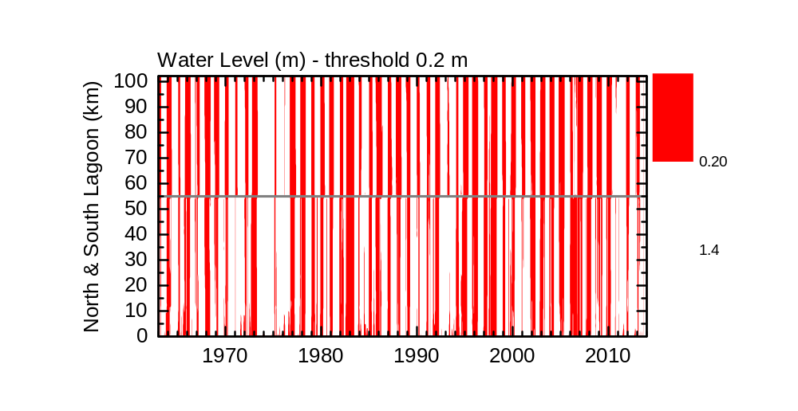
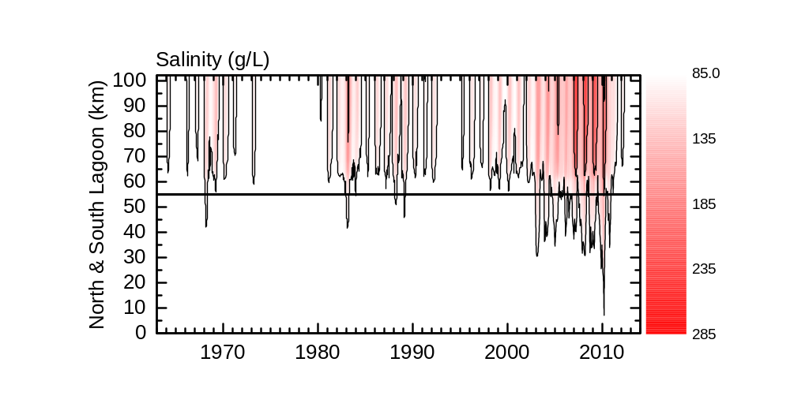
Figure 1: Water level (m AHD) and salinity (g/L) in the Coorong as modelled with CHM v2.1.0. Here focussing on salinities above 85 g/L to be well comparable with fish habitats.

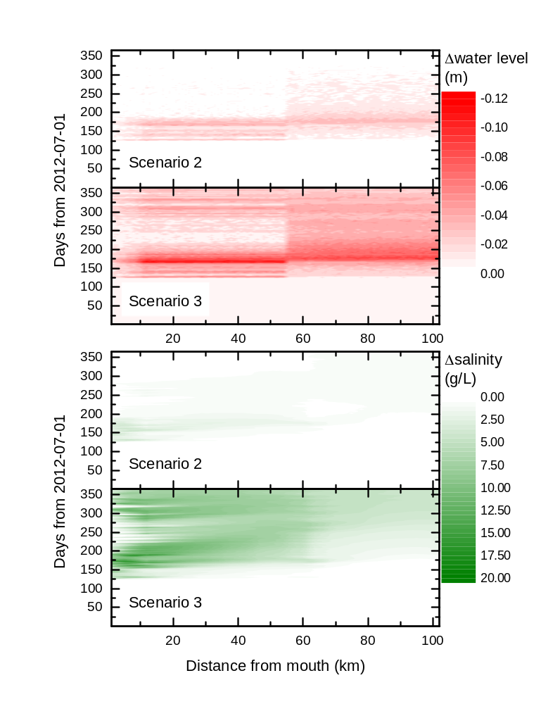
Figure 2: Changes in water level and salinity for scenarios 2 and 3 with respect to the reference.

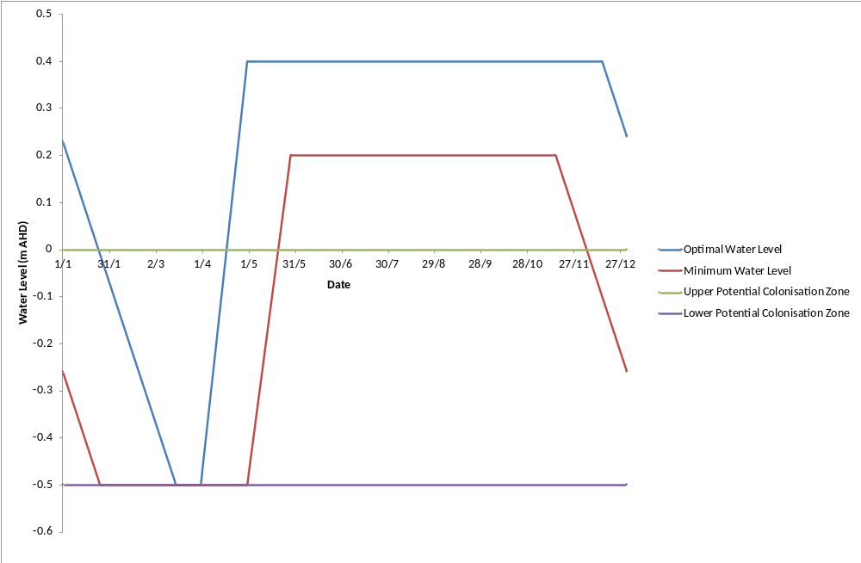
Figure 3: Optimal hydrograph for Ruppia tuberosa in the South Lagoon of the Coorong showing the minimum water levels throughout the year and the elevations where colonisation is likely to occur.
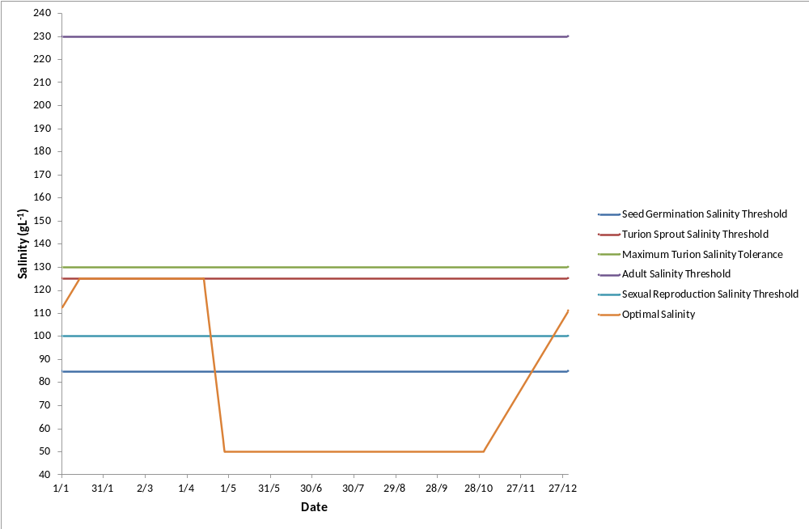
Figure 4: Optimal salinity regime Ruppia tuberosa in the South Lagoon of the Coorong showing the maximum salinity thresholds for adult plants, seed germination, turion sprouting, turion viability and sexual reproduction.

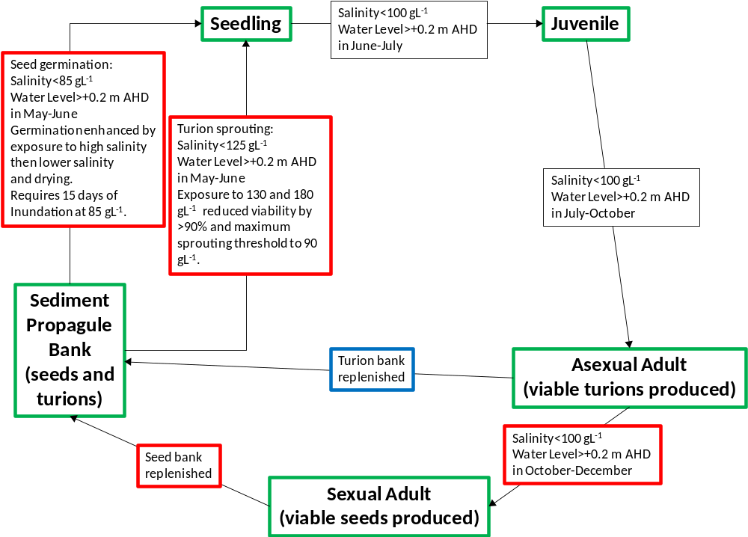
Figure 5: Conceptual model of the life history of Ruppia tuberosa in the South Lagoon of the Coorong. Green boxes represent life history stage, red boxes potential ecological “bottle necks” and the blue box requires more information.

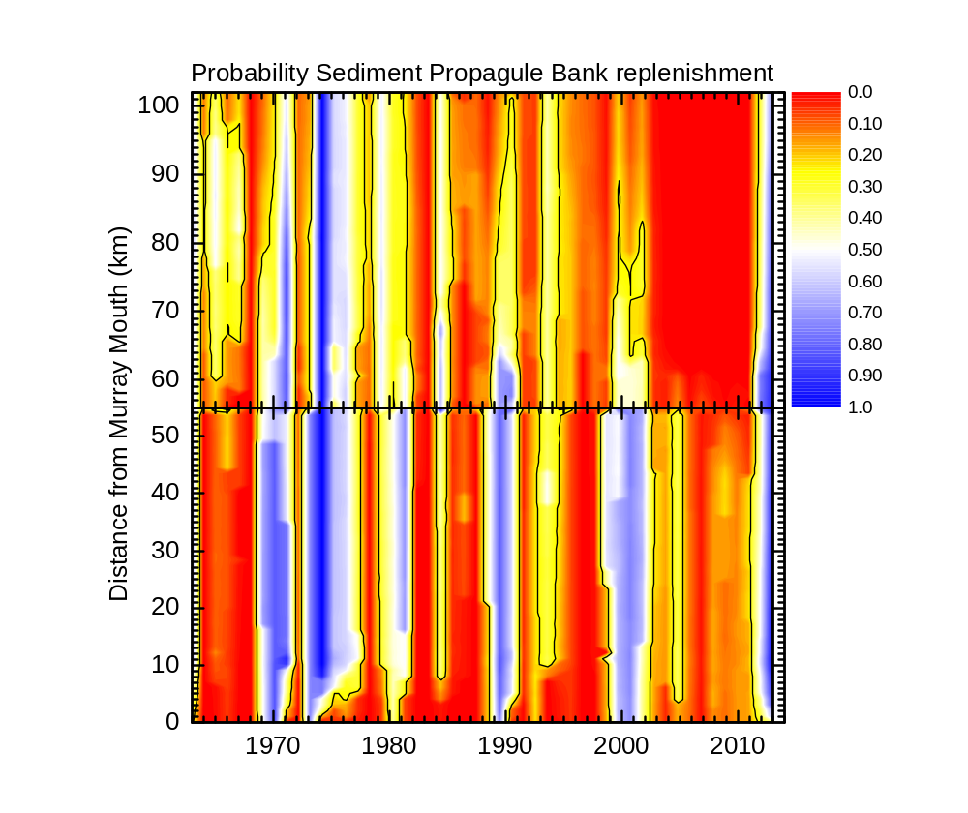
Figure 6: Model output showing the probability of Ruppia tuberosa sediment propagule bank replenishment from 1963 to 2013 in the North Lagoon (lower graph) and South Lagoon (upper graph) of the Coorong between Murray Mouth channel (0 km) and Salt Creek (102 km from the Murray Mouth). The contour line on the plot represents the 25% probability of sediment propagule bank replenishment.
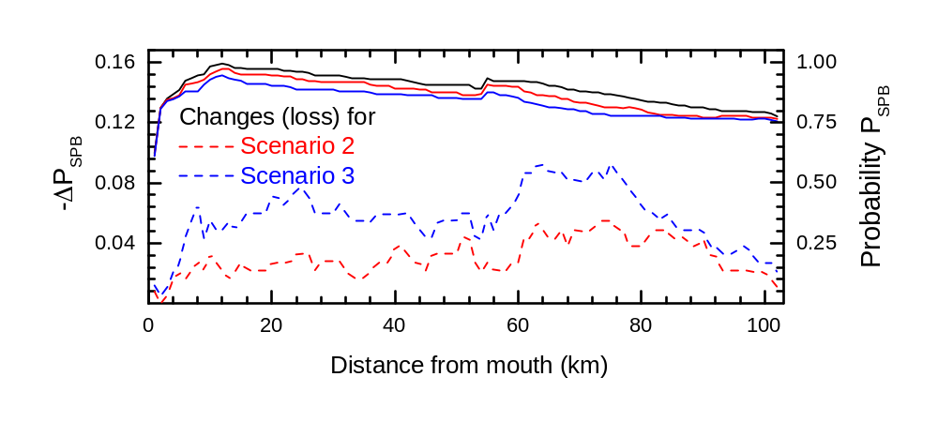
Figure 7: Changes in sediment propagule bank recharge probability for Ruppia tuberosa due to different scenarios of environmental watering (black: reference simulation, red: scenario 2, blue: scenario 3).

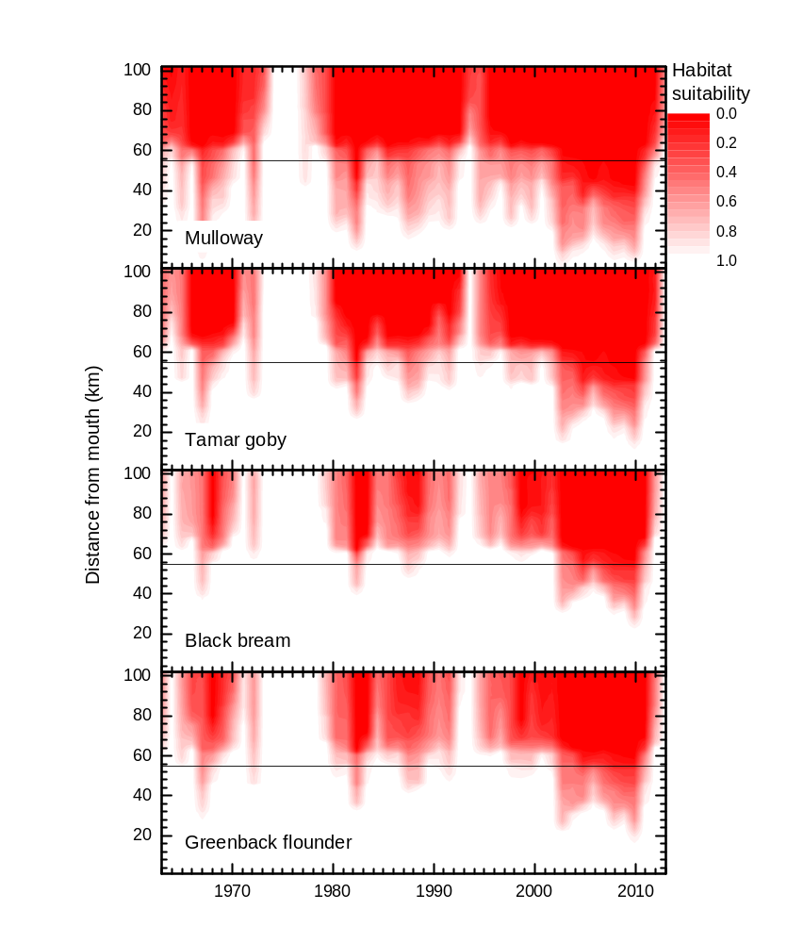
Figure 8: Habitat suitability for fish species in the Coorong calculated on an annual basis. The horizontal black line indicates the border between North and South Lagoon.

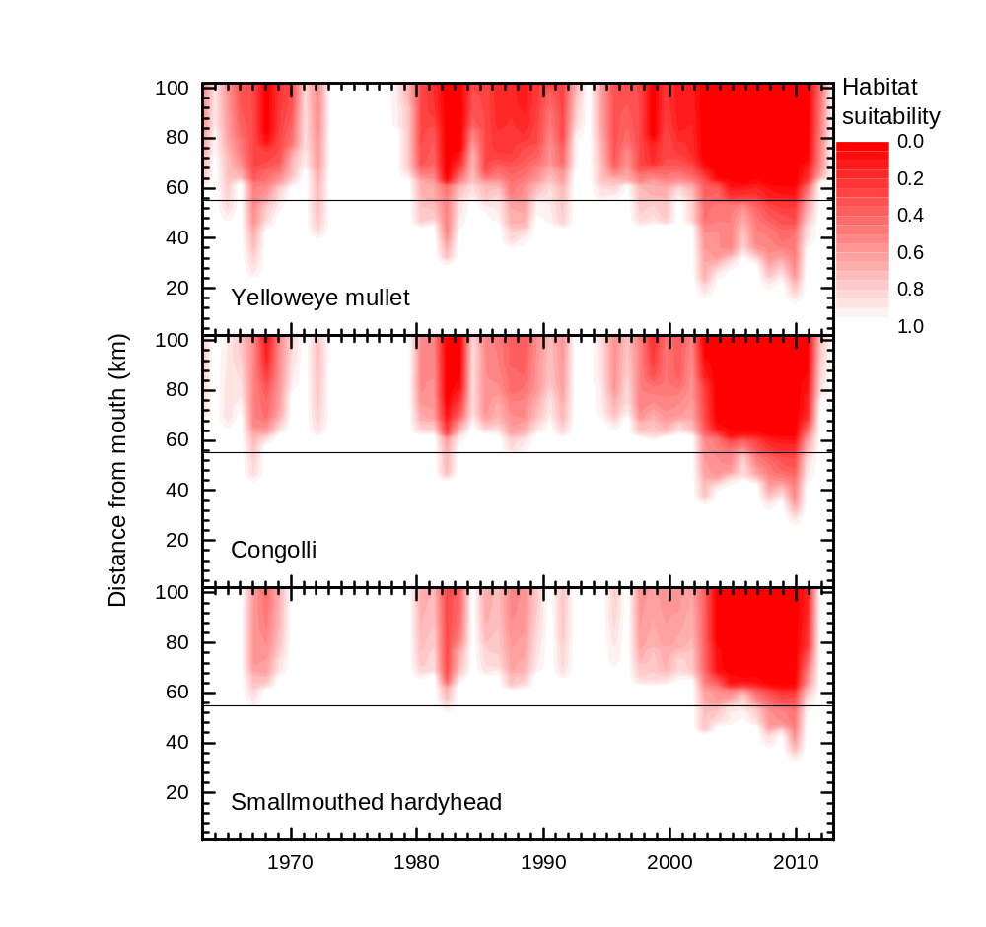
Figure 8 continued: Habitat suitability for fish species in the Coorong calculated on an annual basis. The horizontal black line indicates the border between North and South Lagoon.

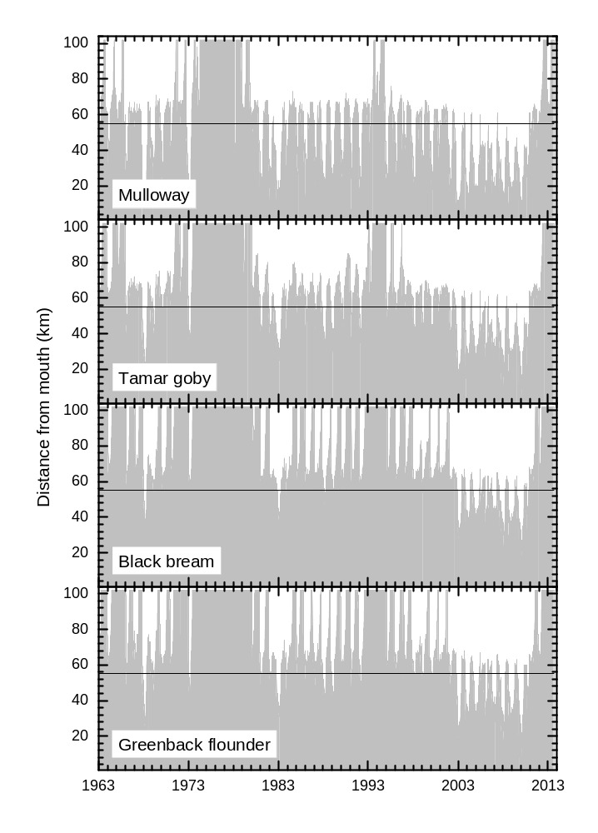
Figure 9: Fish habitat derived from salinity thresholds based on daily analysis.

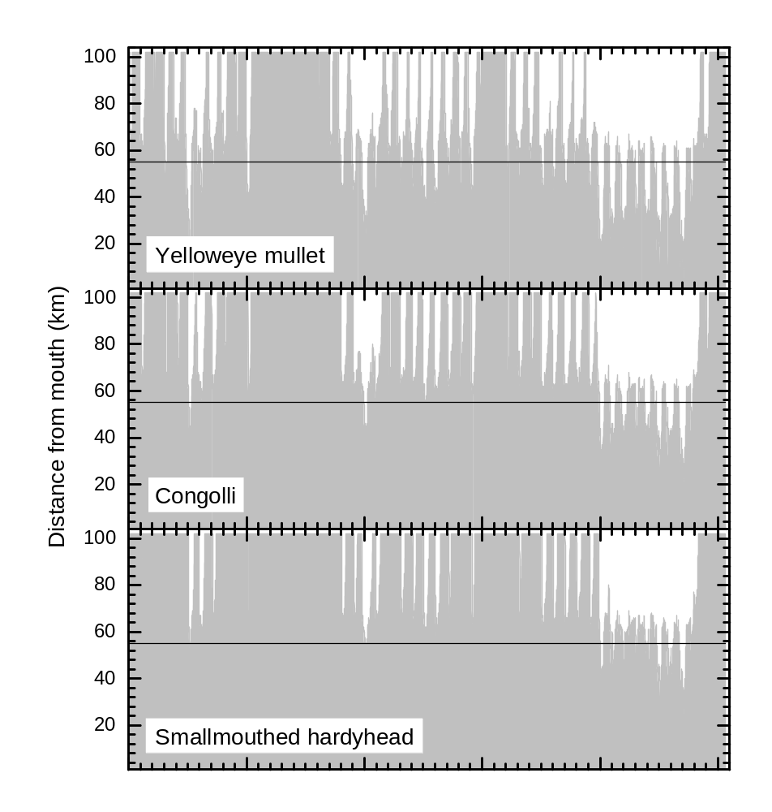
Figure 9 continued: Fish habitat derived from salinity thresholds based on daily analysis.

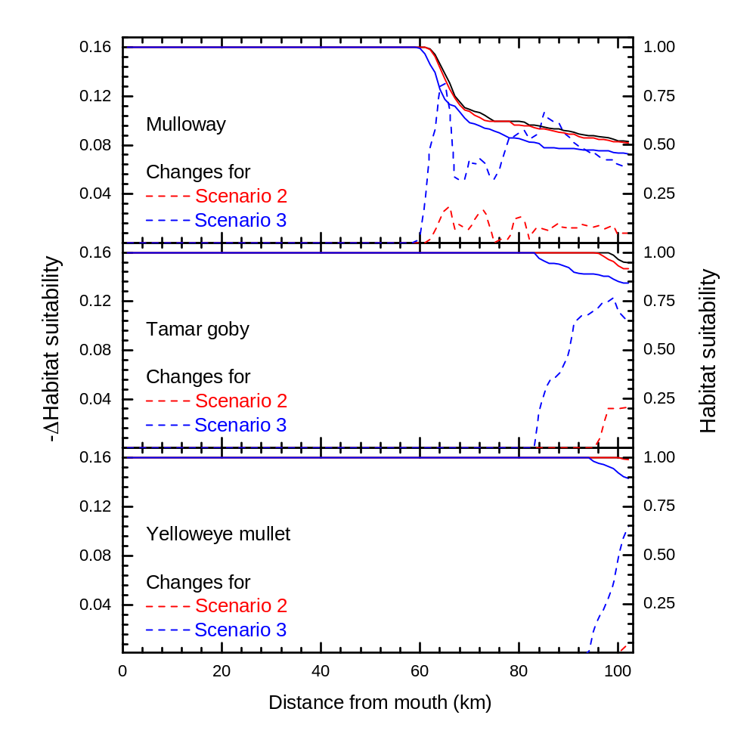
Figure 10: Changes in fish habitat suitability in 2012-13 assuming less barrage flow (scenarios 2 and 3). Species not shown did not experience changes this particular year. A positive value in the habitat changes signifies a loss.

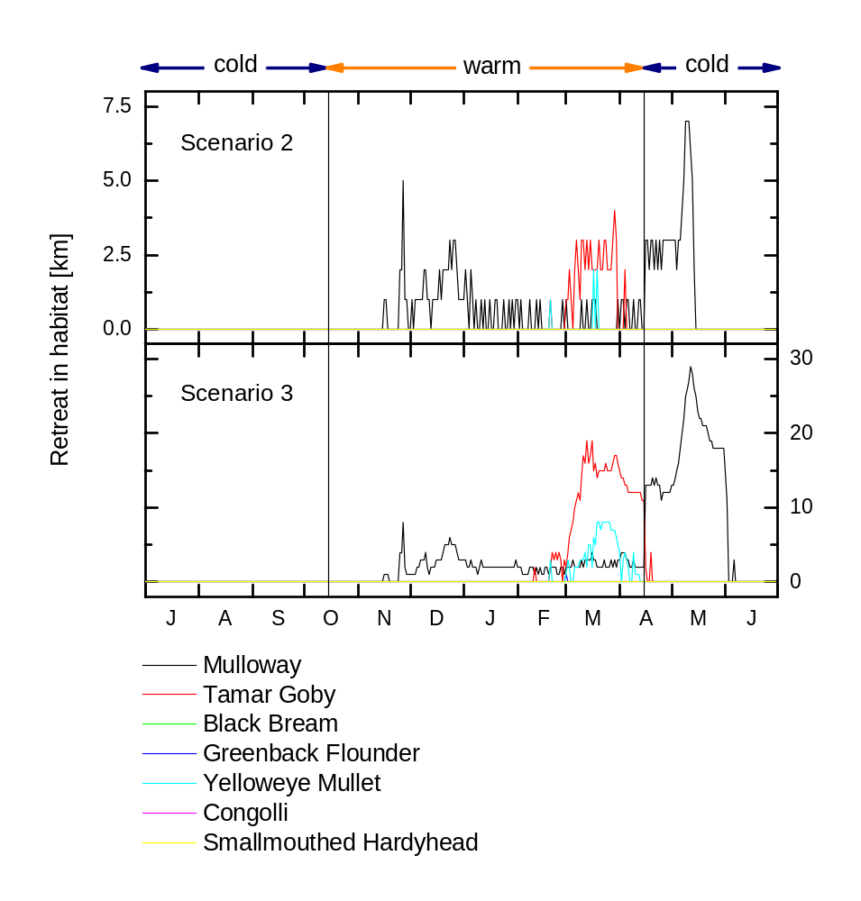
Figure 11: Differences in habitat reach for scenarios 2 and 3 (here retreat with respect to the results of the reference scenario 1). Vertical black lines delineate cold from warm periods.

